Broens,Michelle J.J.

GD43 | GTO4

Turn-based local battle

My project

Contents

Introduction to the game 2

DOT-Framework Strategy 3

Library 3

Workshop 3

Iteration 1 proof of concept 4

Iteration 2 proof of concept 4

Iteration 3 proof of concept 4

Iteration 4 proof of concept 4

Lab 4

Showroom 4

Deliverables 5

# Introduction to the game

The game is a local multiplayer battle where two players can play. They switch turns one player gets to move and the other gets to use skills to damage the other player. On the top of the screen there is a timer that displays how long a round has been going on. Each player has a set amount of health and the player that depletes the other’s health first, wins.

# DOT-Framework Strategy

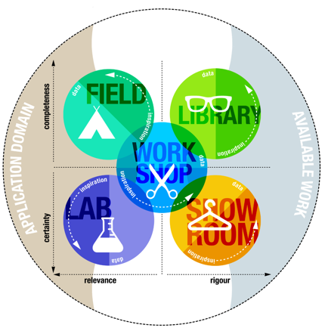

# Library

Start by analyzing similar games, stuff like Clash Royale. From this there will be a conclusion drawn to see what games like this have in common and what the most important requirements are.

Unity forums and documentation:

<https://forum.unity.com/threads/good-way-of-implementing-a-timer.53930/>

<https://answers.unity.com/questions/60249/timer-repeated-function-coroutine.html>

<https://answers.unity.com/questions/896755/enabledisable-game-objects-after-wait-for-seconds.html>

These sources were used to understand and implement the use of repeated coroutines.

Wondered what the best way to implement health bars was so this source was used to implement health bars:

<https://answers.unity.com/questions/11892/how-would-you-make-an-energy-bar-loading-progress.html>

Timer in coroutine:

<https://answers.unity.com/questions/1404422/create-a-countdown-in-c-inside-coroutine.html>

Sources about scriptable objects, this was not enough to help implement the scriptable objects.

<http://wiki.unity3d.com/index.php?title=CreateScriptableObjectAsset>

<https://docs.unity3d.com/Manual/class-ScriptableObject.html>

# Workshop

A proof of concept will be made with use of the requirements, this proof of concept will be used to set up a paper prototype. The game will have integrated modules from the workshop to set up a basic structure.

During Game Design Basics we’ve paper prototyped this game and tried multiple things. This project is a continuation and digitalization of that game. We’ve tried an objective which you need to move across the map to obtain while the other player tried to stop you with skills. There were 4 rounds and the one who got the most objective points won the game. We’ve tested this game with multiple people and the game has changed multiple times. You can read more about this in the GDB document.

## Iteration 1 proof of concept

The first iteration was to test if the core gameplay was fun. It had two playable characters and two different skills, they both came form the left of the screen and went to the right, one was placed higher than the other. So, you had to dodge the skills the other player sent while sending your own skills to the other player. If you got hit 10 times you lost. The player could move up, left and right, there was also a dash which you could use.

During playtest we’ve noticed that the game was a little bit too hard. Players had trouble moving the player while sending out skills.

## Iteration 2 proof of concept

After the first iteration we’ve tried to find solutions for the controls and gameplay. The game was too hard for players to properly play. In the second iteration we still have 2 players and they send skills to eachother. But this time around only 1 player moves, and the other player sends the skills. The goal is now to survive as long as you can and get a high score. This game was more fun for the players but didn’t have the competitiveness that we were hoping for.

## Iteration 3 proof of concept

In this iteration we’ve made the players switch turns. 1 player moves his character and the other sends skills to defeat the first player. Every 15 seconds they switch roles. The one who hits the other player 10 times wins.

During playtests they’ve said the skills were too bland and you didn’t have enough influence over them.

## Iteration 4 proof of concept

In this iteration we added a new skill. The player can control this skill by pressing the button of the skill again. This was a little too over powered, so we changed the way the movement works, the player can now press a down key to get to the ground faster to make it easier for the player to dodge the new skill.

# Lab

The prototype made before will be tested on the intended users. From the results of these tests the core gameplay will be tweaked to satisfy the users.

# Showroom

Once the proof of concept is finished there will be a few peer review sessions with the fitting Community of Practice. The feedback from this will be collected and used to further improve the game.

# Deliverables

A functioning proof of concept with the following features:

* A simple design of the level
* Multiplayer “turn-based” core gameplay that will involve the players using skills to battle each other, this will involve a win/defeat condition.
* The players trade turns to walk and use skills, the player that can kill the other player with skills the fastest wins.